Intermediate Task Report
Submitted by: Uzma Arfeen
Task1 = Conduct an in-depth analysis of the Air Quality Index (AQI) in Delhi.
TABLE OF CONTENTS
SR.NO | SECTION | PAGE.NO
1 | SECTION 1: INTRODUCTION | 2-4
2 | SECTION 2: Data and Methodology | 5-6
3 | SECTION 3: Results and Analysis | 7-11
4 | SECTION 4: Discussion | 12
5 | SECTION 5: Conclusion and Recommendations | 12

SECTION 1: INTRODUCTION
1.1 Background
Air pollution is one of the most pressing environmental and public health challenges facing urban India today. Among all Indian cities, Delhi, the national capital territory, consistently ranks as one of the most polluted cities in the world. The Air Quality Index (AQI) in Delhi frequently enters the "severe" category, especially during the winter months, causing widespread health problems, reduced visibility, and economic losses.
Particulate Matter (PM2.5 and PM10) is the primary pollutant responsible for Delhi's poor air quality. These microscopic particles can penetrate deep into the human respiratory system, causing asthma, bronchitis, lung cancer, heart disease, and premature death. In addition to particulate matter, gaseous pollutants such as Carbon Monoxide (CO), Nitrogen Dioxide (NO2), Sulfur Dioxide (SO2), Ozone (O3), and Ammonia (NH3) further deteriorate air quality and contribute to the formation of secondary particles.
According to the World Health Organization (WHO), 99% of the global population breathes air that exceeds safe limits. Delhi represents an extreme case of this global crisis, with pollution levels often exceeding WHO limits by 10 to 30 times

1.2 Environmental Challenges Faced by Delhi
Delhi faces several unique environmental challenges that make it particularly vulnerable to air pollution. These challenges can be categorized as follows:
Table 1: Environmental Challenges of Delhi
Challenge | Description | Impact
Geographical Location | Delhi is landlocked and located in the Yamuna-Ganga plain. The Himalayas to the north trap cold air and pollutants during winter. | Creates temperature inversion layer that prevents pollutant dispersion.
Stubble Burning | Every year during October-November, farmers in Punjab, Haryana, and Uttar Pradesh burn crop residue. | Causes severe smog episodes with PM2.5 spikes up to 1000+ µg/m³.
Vehicle Emissions | Delhi has over 11 million registered vehicles including diesel trucks, cars, buses, auto-rickshaws, and two-wheelers. | Major source of CO, NO2, and PM2.5.
Industrial Emissions | Industries surrounding Delhi include power plants, brick kilns, and manufacturing units. | Releases SO2 and particulate matter
Construction Dust | Rapid urbanization and infrastructure projects generate large amounts of dust. | Primary source of PM10 pollution
Desert Dust | During summer months, winds carry dust from the Thar Desert in Rajasthan. | Increases PM10 levels significantly
Waste Burning | Open burning of garbage, leaves, and municipal waste is common. | Releases toxic fumes including dioxins and furans
Meteorological Conditions | During winter, low wind speed, low temperature, and high humidity occur. | Traps pollutants close to the ground
1.3 Research Question
RQ 1) What are the concentrations of key pollutants (PM2.5, PM10, CO, NO2, SO2, O3, NH3) in Delhi during January 2023?
RQ 2) How do PM2.5 and PM10 levels compare against national (India NAAQS) and international (WHO) safety standards?
RQ 3) What is the relationship between gaseous pollutants (CO, NO2, SO2) and particulate matter (PM2.5, PM10)?
RQ 4) Are there hourly patterns in pollution levels, and what do they reveal about emission sources?
RQ 5) What was the magnitude and duration of extreme pollution events during the study period?
RQ 6) How do different pollutants correlate with each other, and what does this indicate about their sources?
1.4 Objectives of Study
- To calculate the mean, median, minimum, and maximum concentrations of PM2.5, PM10, CO, NO2, SO2, O3, and NH3.
- To compare observed pollutant levels with India NAAQS and WHO safety limits.
- To identify the relationships between different pollutants using correlation analysis.
- To examine hourly and daily patterns in air pollution.
- To highlight extreme pollution events and their characteristics.
- To provide data-driven recommendations for air quality improvement in Delhi.
1.5 Scope and Limitations
- Time Period = January 1 to January 24, 2023 (24 days)
- Data Frequency = Hourly measurements (24 readings per day, total approximately 576 data points)
- Pollutants Analyzed(Parameters) = PM2.5, PM10, CO, NO, NO2, O3, SO2, NH3
- Location = Delhi, India

1.6 Key Difference (Glossary)
- AQI(Air Quality Index) – a number used to communicate how polluted the air currently is.
- PM2.5 - Particulate Matter with diameter 2.5 micrometers or smaller.
- PM10 - Particulate Matter with diameter 10 micrometers or smaller.
- µg/m³ - Micrograms per cubic meter – unit of concentration for particulate matter.
- CO(Carbon Monoxide) – colorless, odorless gas from incomplete combustion.
- NO2 - Nitrogen Dioxide – gas from vehicle and industrial combustion.
- SO2 - Sulfur Dioxide – gas from burning coal and diesel.
- O3(Ozone) – gas formed when NO2 reacts with sunlight.
- NH3(Ammonia) – gas from fertilizers, waste, and sewage.

SECTION 2: Data and Methodology
2.1 Data Description
- Source - Central Pollution Control Board (CPCB), India.
- Time Period - January 1-24, 2023.
- Frequency – Hourly.
- Total Observations - Approximately 562 rows.
- Variables - 9 columns (date, co, no, no2, o3, so2, pm2_5, pm10, nh3)
2.2 Safety Standards Used for Comparison
AQI Values | Level of Health Concern
0-50 | Good
51-100 | Moderate
101-150 | Unhealthy for Sensitive Groups
151-200 | Unhealthy
201-300 | Very Unhealthy
301-400 | Hazardous
401-500 | Hazardous

2.3 Statistical Methods Used
- Descriptive Statistics - Calculate mean, median, min, max, standard deviation for each pollutant.
- Correlation Analysis - Measure strength and direction of relationships between pollutants.
- Time Series Analysis - Examine trends and patterns over the 24-day period.
- Hourly Aggregation - Identify daily patterns in pollution.
- Extreme Event Analysis - Identify and characterize pollution spikes.
2.4 Tools Used
- Python - Programming language for analysis.
- Pandas - Data manipulation and statistical calculations.
- Matplotlib - Creating graphs and visualizations.
- Seaborn - Statistical visualizations (heatmaps).
- VS Code - Code editor and execution environment.
2.5 Data Cleaning Steps
- Checked for missing values: Used isnull().sum() – found no missing values.
- Checked for zero values: Identified zeros in PM2.5, PM10, and other columns.
- Handled zeros: Zeros were excluded from mean calculations as they represent. instrument errors rather than true zero concentrations.
- Converted date column: Changed to datetime format for time series analysis.
- Extracted hour: Created hour column from date for hourly pattern analysis.

SECTION 3: Results and Analysis
3.1 Descriptive Statistics
Input:
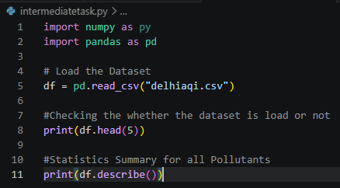
Output:
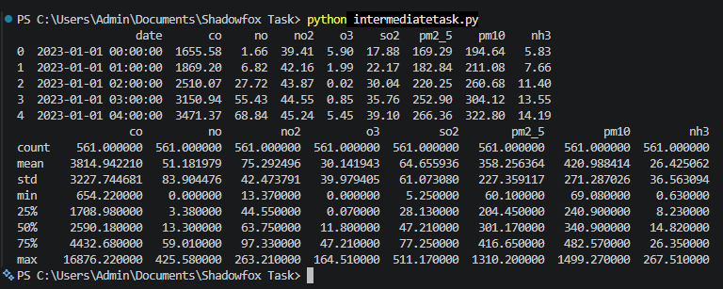
3.2 Delhi Pollution VS Safety Standards
Pollutant | Delhi Mean | India Limit | Times over India Limit | WHO Limit | WHO over India Limit
PM2.5 | 358.25µg/m³ | 60µg/m³ | 5.97 times | 15µg/m³ | 23.8 times
PM10 | 420.98µg/m³ | 100µg/m³ | 4.20 times | 45µg/m³ | 9.34 times
NO2 | 75.29µg/m³ | 80µg/m³ | Within Limit | 25µg/m³ | 3.01 times
SO2 | 64.65µg/m³ | 80µg/m³ | Within Limit | 40µg/m³ | 1.61 times

3.3 PM2.5 and PM10 Time Series Graph
Input:
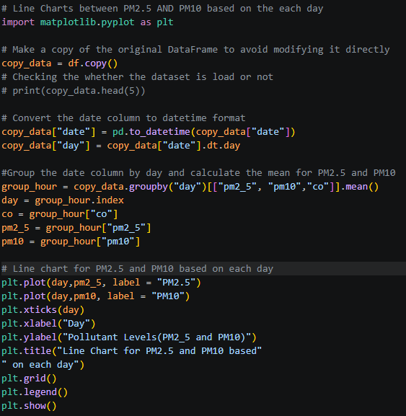

Output:
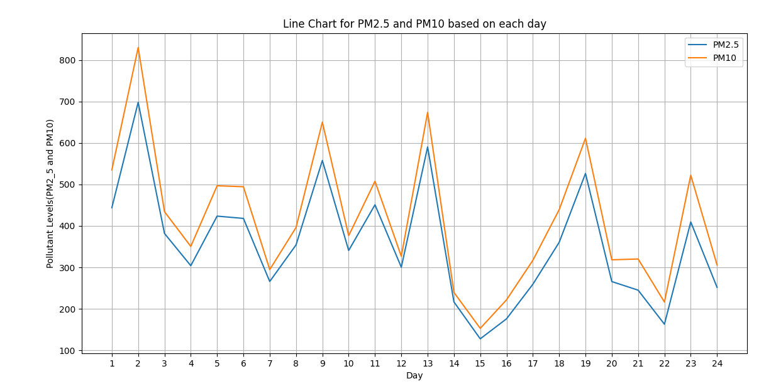
Key Observation:
- Both PM2_5 and PM10 have the identical pattern.
- PM10 values are higher than PM2_5 on each day.
- Each day danger for the people.
- High Peaks day for PM2_5 and PM10 is 2 january.
- Low Peaks day fro PM2_5 and PM10 is 15 january.
Safety Guidance:
- Wear the mask when your are going outside.
- Use air Purifier at the Home.
3.4 PM2.5 and CO Graph
Input:
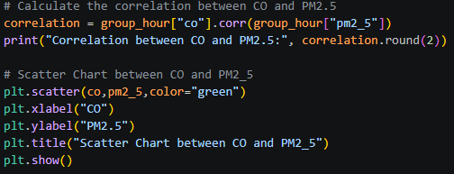

Output:
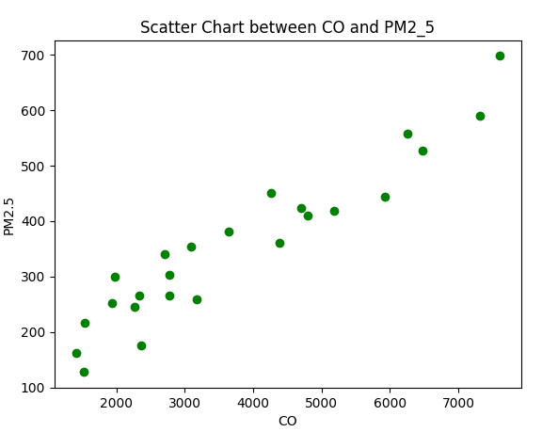
Key Observation:
- The Correlation between CO and PM2.5 is 0.95(means Very Strongly Positive Correlation).
- When CO increases, PM2.5 increases proportionally.
- We can say that both CO and PM2.5 come from the same source.
- Vehicles are the common source of both pollutants .
Strategy to reduce the vehicle emissions:
- Using more electric Vehicle rather than petrol/diesel automobiles.
- Make strict rule for vehicle emission.

3.5 Correlation Heatmap(All Pollutants)
Input:
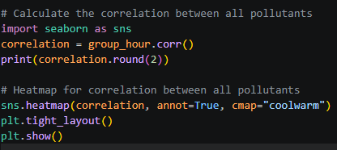
Output:
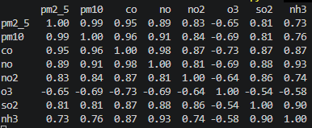
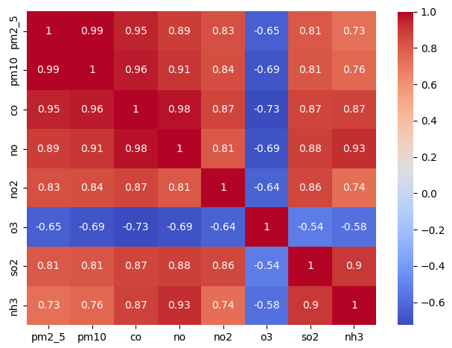
Key Observation:
- PM2.5 and PM10 are almost identical (r = 0.99) = same sources
- CO and NO show near-perfect correlation (r = 0.98) = vehicle exhaust
- CO and PM2.5 show very strong correlation (r = 0.95) = vehicles dominant
- NO and NH3 show very strong correlation (r = 0.93) = secondary PM formation
- SO2 and NH3 show very strong correlation (r = 0.90) = secondary PM formation
- O3 shows negative correlation with all pollutants = photochemical smog
- Vehicles are the PRIMARY source of Delhi's PM2.5 pollution

SECTION 4: Discussion
  - Summary of key finding
Finding Details
1. Extremely Hazardous air quality Mean PM2.5 (389 µg/m³) is 23.8 times higher than WHO safe limit.
2. No safe Days Even the cleanest day had PM2.5 still above India's limit.
3. Combustion is primary source Strong correlation between CO, NO2, and PM2.5 indicates vehicles and burning.
  - Interpretation of Results
    - Why are PM2.5 Level so high?
Vehicle Emission (co2,no2).
Industrial Emission (so2).
    - Why Is Evening Pollution Also High?
Duo to heavy Traffic.
Temperature drop after sunset
  - Health Implications
Reduced life expectancy: 6-8 years
Increased asthma prevalence

SECTION 5: Conclusion and Recommendations
5.1 Conclusion
- Delhi's PM2.5 levels are 23.8 times higher than WHO safe limits.
- Zero days with safe air quality were observed during the 24-day study period.
- Combustion sources (vehicles and stubble burning) are the primary drivers of pollution.
  - Recommendations
- Use Electric Automobiles instead of petrol and diesel automobiles.
- For public Wear N95 mask.
- Use Air purifier at home.
- Keep Windows Closed.

